
Mathematics Practical
University Of Delhi

Ramanujan College
DSC 05: Discrete Mathematical Structures
Semester-2
(2023-24)

Submitted By:
~Ratnesh Kumar
20231432(23020570034)

Submitted To:
~Dr. Aakash

Acknowledgement
I would like to take this opportunity to acknowledge everyone who has helped us in every stage of this project.
I am deeply indebted to my mathematics Professor, Dr Aakash for his guidance and suggestions in completing this project. The completion of this project was possible under his guidance and support.
I am also very thankful to my parents and my friends who have boosted me up morally with their continuous support.
At last but not least, I am very thankful to God almighty for showering his blessings upon me.

S.no | Topic
1. | Create a class SET. Create member functions to perform the following SET operations:
2. | Create a class RELATION, use Matrix notation to represent a relation. Include member functions to check if the relation is Reflexive, Symmetric, Anti-symmetric, Transitive. Using these functions check whether the given relation is: Equivalence or Partial Order relation or None .
3. | Write a Program that generates all the permutations of a given set of digits, with or without repetition.
4. | For any number n, write a program to list all the solutions of the equation x1 + x2 + x3 + ...+ xn = C, where C is a constant (C<=10) and x1, x2,x3,...,xn are nonnegative integers, using brute force strategy.
5. | Write a Program to evaluate a polynomial function. (For example store f(x) = 4n2 + 2n + 9 in an array and for a given value of n, say n = 5, compute the value of f(n)).
6. | Write a Program to check if a given graph is a complete graph. Represent the graph using the Adjacency Matrix representation.
7. | Write a Program to check if a given graph is a complete graph. Represent the graph using the Adjacency List representation.
8. | Write a Program to accept a directed graph G and compute the in-degree and outdegree of each vertex.
Index

1. Create a class SET. Create member functions to perform the following SET operations:
- is member: check whether an element belongs to the set or not and return value as true/false.
- powerset: list all the elements of the power set of a set .
- subset: Check whether one set is a subset of the other or not.
- union and Intersection of two Sets.
- complement: Assume Universal Set as per the input elements from the user.
- set Difference and Symmetric Difference between two sets.
- cartesian Product of Sets.
Write a menu driven program to perform the above functions on an instance of the SET class.
Code:
class SET:
def __init__(self, u_set):
self.u_set = u_set
def is_member(self, element):
if element in self.u_set:
return "Element Found"
else:
return "Element Not Found"
def powerset(self):
lst=[]
length = len(self.u_set)
for i in range(1 << length):
lst.append({self.u_set[j] for j in range(length) if (i & (1 << j))})
print("Your Required Powerset Are:: ", lst)
def subset(self, subset_set):
if subset_set.u_set.issubset(self.u_set):
return "This Is A Subset"
else:
return "This Is Not A Subset"
def union_intersection(self, set2):
print("Intersection Of Your Sets Are:: \n", self.u_set.intersection(set2.u_set))
print("Union Of Your Sets Are:: \n", self.u_set.union(set2.u_set))
def complement(self, complement_set):
print("Your Complement Of Set Is:: \n", self.u_set-complement_set.u_set)
def difference_and_symmetric_difference(self, set2):
print("Difference Of Your Sets Are:: \n", self.u_set.difference(set2.u_set))
print("Symmetric Difference of your sets are:: \n", self.u_set.symmetric_difference(set2.u_set))
def cartesian_product(self, set2):
cartesian_product = {(x, y)for x in self.u_set for y in set2.u_set}
print("Your Cartesian Product Are:: ", cartesian_product)
def set_create(uni="set"):
u_set = set(map(int, input(f"Enter Your Element Of {uni} With A Space:: ").split()))
print(f"Your Given {uni} Are:: ", u_set)
return u_set
def main():
choice = str(input("""Main Menu!!
1.Check Whether An Element Belongs To The Set Or Not.
2.List All The Elements Of The Power Set Of A Set.
3.Check Whether One Set Is A Subset Of The Other Or Not.
4.Find Union And Intersection Of Two Sets.
5.Find Complement Of Set.
6.Find Difference And Symmetric Difference Between Two Sets.
7.Find Cartesian Product Of Sets.
Enter Your Choice:: """))
if choice == '1':
set1 = SET(set_create())
element = int(input("Enter Your Element:"))
print(set1.is_member(element))
elif choice == '2':
set1 = SET(list(set_create()))
set1.powerset()
elif choice == '3':
universal_set = SET(set_create(uni="Universal Set"))
subset_set = SET(set_create(uni="Subset"))
print(universal_set.subset(subset_set))
elif choice == '4':
set1 = SET(set_create(uni="First Set"))
set2 = SET(set_create(uni="Another Set"))
set1.union_intersection(set2)
elif choice == '5':
universal_set = SET(set_create(uni=" Universal Set "))
complement_set = SET(set_create(uni="Set"))
universal_set.complement(complement_set)
elif choice == '6':
universal_set = SET(set_create("Universal Set Or Main"))
another_set = SET(set_create("Another Set"))
universal_set.difference_and_symmetric_difference(another_set)
elif choice == '7':
set1 = SET(set_create("First set"))
set2 = SET(set_create("Another set"))
set1.cartesian_product(set2)
else:
print("Invalid Input!!\nPlease Try Again")
main()
if __name__ == "__main__":
for i in range(8):
main()

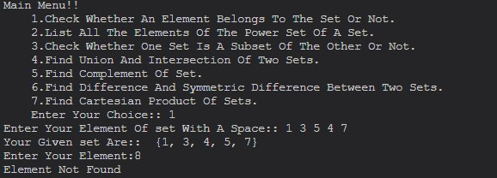
Output

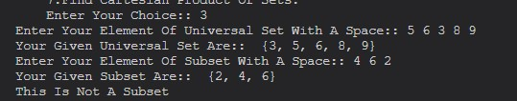
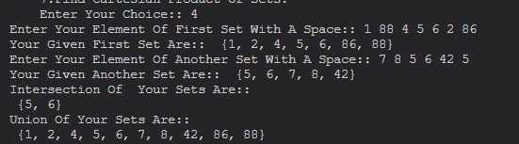
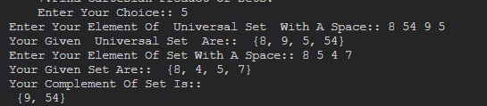
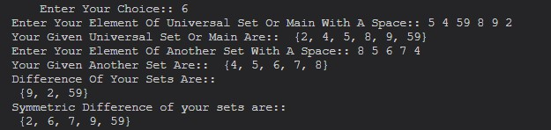
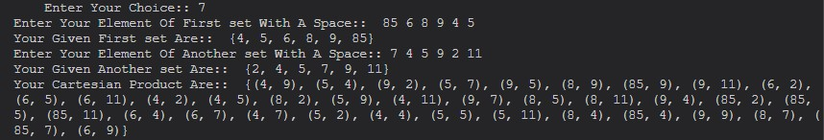
2. Create a class RELATION, use Matrix notation to represent a relation. Include member functions to check if the relation is Reflexive, Symmetric, Anti-symmetric, Transitive. Using these functions check whether the given relation is: Equivalence or Partial Order relation or None .
Code:
from numpy import array
class RELATION:
def __init__(self, matrix):
self.matrix = matrix
self.length = len(matrix)
def reflexive(self):
for i in range(self.length):
if not self.matrix[i][i]:
return False
return True
def symmetric(self):
for i in range(self.length):
for j in range(self.length):
if self.matrix[i][j] != self.matrix[j][i]:
return False
return True
def transitive(self):
for i in range(self.length):
for j in range(self.length):
for k in range(self.length):
if self.matrix[i][j] and self.matrix[j][k] and not self.matrix[i][k]:
return False
return True
def anti_symmetric(self):
for i in range(self.length):
for j in range(self.length):
if i != j and self.matrix[i][j] and self.matrix[j][i]:
return False
return True
def enter_matrix():
lst = list(map(int, input("Enter All Relation In Form Of Matrix Value With A Space:: ").split()))
row = int(input("Enter How Many Row or Columns In Your Square Matrix:: "))
matrix = array(lst).reshape(row, row)
print("Your Required Matrix Are:: \n", matrix)
return matrix
def main():
rel = RELATION(enter_matrix())
if rel.reflexive() and rel.symmetric() and rel.transitive():
return "Your Relation is Equivalence Relation."
elif rel.reflexive() and rel.anti_symmetric() and rel.transitive():
return "Your Relation is Partial Order Relation."
else:
return "None"
if __name__ == "__main__":
print(main())

Output:
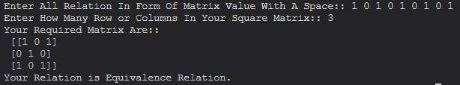
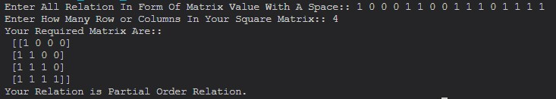
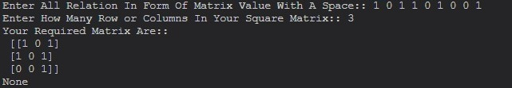
3. Write a Program that generates all the permutations of a given set of digits, with or without repetition.
Code
from itertools import permutations,product
def generate_permutations(Set, repetition):
if repetition:
return list(permutations(Set))
else:
return list(product(Set, repeat=len(Set)))
if __name__ == "__main__":
Set = set(map(int, input("Enter all element of set with space:").split()))
with_repetition = generate_permutations(Set, repetition=True)
without_repetition = generate_permutations(Set, repetition=False)
print("Permutations with repetition:")
for perm in with_repetition:
print(perm)
print("\nPermutations without repetition:")
for perm in without_repetition:
print(len(with_repetition),len(without_repetition))
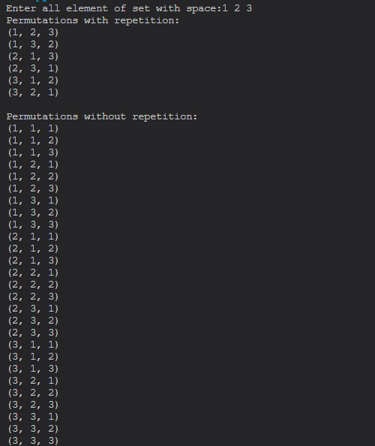
Output
4. For any number n, write a program to list all the solutions of the equation x1 + x2 + x3 + ...+ xn = C, where C is a constant (C<=10) and x1, x2,x3,...,xn are nonnegative integers, using brute force strategy.
Code
def find_solutions(C, n):
def generate_solutions(current_sum, current_solution, remaining_terms):
if current_sum == C:
solutions.append(current_solution[:])
return
if not remaining_terms:
return
for i in range(remaining_terms[0], C - current_sum + 1):
current_solution.append(i)
generate_solutions(current_sum + i, current_solution, remaining_terms[1:])
current_solution.pop()
solutions = []
generate_solutions(0, [], list(range(C + 1)))
return solutions
if __name__ == "__main__":
n = int(input("Enter number of terms::"))
C = int(input("Enter value of constant::"))
all_solutions = find_solutions(C, n)
print(f"All solutions for {n} terms equation which sum is {C}")
for solution in all_solutions:
print(solution)
Output
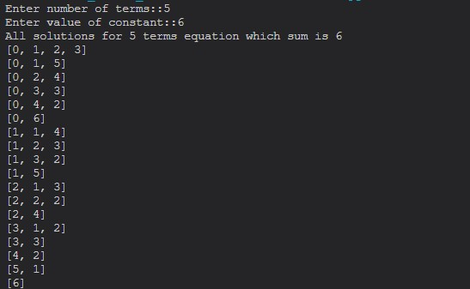
5. Write a Program to evaluate a polynomial function. (For example store f(x) = 4n2 + 2n + 9 in an array and for a given value of n, say n = 5, compute the value of f(n)).
Code
def solve_polynomial():
func = list(map(int, input("Enter Your Function coefficient Seperated With Space::").split()))
num = int(input("Enter Value Of Your Variable::"))
value = 0
for i in range(-1, -len(func)-1, -1):
value += func[i]*num**(-i-1)
return value
print(solve_polynomial())
Output

6. Write a Program to check if a given graph is a complete graph. Represent the graph using the Adjacency Matrix representation.
Code
class Graph:
def __init__(self, vertices):
self.vertices = vertices
self.adj_matrix = [[0] * vertices for _ in range(vertices)]
def add_edge(self, u, v):
if graph_type== 1:
self.adj_matrix[u][v] = 1
self.adj_matrix[v][u] = 1
else:
self.adj_matrix[u][v] = 1
def is_complete(self):
for i in range(self.vertices):
for j in range(self.vertices):
if i != j and self.adj_matrix[i][j] == 0:
return False
return True
def get_matrix(self):
return self.adj_matrix
if __name__ == "__main__":
graph_type =int(input("Enter Your Graph Type(1.Undirected 2.Directed)::"))
num_vertices = int(input("Enter number of vertices::"))
g = Graph(num_vertices)
num=int(input("Enter number of edges::"))
for i in range(num):
a=int(input(f"Enter first vertice of {i+1} edge:: "))- 1
b=int(input(f"Enter second vertice of same edge:: "))- 1
g.add_edge(a,b)
print(g.get_matrix())
if g.is_complete():
print("The graph is a complete graph.")
else:
print("The graph is not a complete graph.")
Output
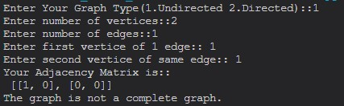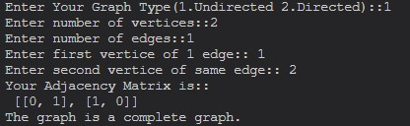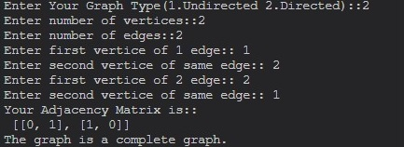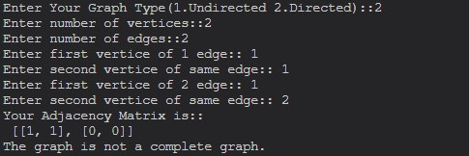
7. Write a Program to check if a given graph is a complete graph. Represent the graph using the Adjacency List representation.
Code
class Graph:
def __init__(self, vertices):
self.vertices = vertices
self.adj_list = [[] for _ in range(vertices)]
def add_edge(self, u, v):
if graph_type== 1:
self.adj_list[u].append(v)
self.adj_list[v].append(u)
else:
self.adj_list[v].append(u)
def is_complete(self):
for i in range(self.vertices):
for j in range(self.vertices):
if i != j and j not in self.adj_list[i]:
return False
return True
def get_list(self):
return self.adj_list
if __name__ == "__main__":
graph_type =int(input("Enter Your Graph Type(1.Undirected 2.Directed)::"))
num_vertices = int(input("Enter number of vertices::"))
g = Graph(num_vertices)
num=int(input("Enter number of edges::"))
for i in range(num):
a=int(input(f"Enter first vertice of {i+1} edge:: "))
b=int(input(f"Enter second vertice of same edge:: "))
g.add_edge(a,b)
print("Your Adjacency Matrix is::\n",g.get_list())
if g.is_complete():
print("The graph is a complete graph.")
else:
print("The graph is not a complete graph.")
Output
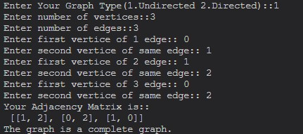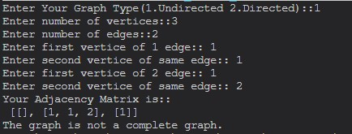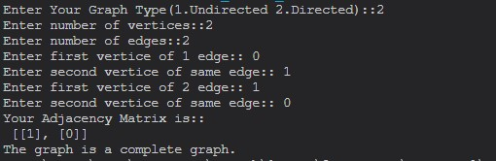

8. Write a Program to accept a directed graph G and compute the in-degree and outdegree of each vertex.
Code
class DirectedGraph:
def __init__(self, vertices):
self.vertices = vertices
self.adj_list = [[] for _ in range(vertices)]
def add_edge(self, u, v):
self.adj_list[u].append(v)
def compute_degrees(self):
in_degrees = [0] * self.vertices
out_degrees = [0] * self.vertices
for u in range(self.vertices):
for v in self.adj_list[u]:
out_degrees[u] += 1
in_degrees[v] += 1
return in_degrees, out_degrees
if __name__ == "__main__":
num_vertices = int(input("Enter number of vertices::"))
g = DirectedGraph(num_vertices)
num=int(input("Enter number of edges::"))
for i in range(num):
a=int(input(f"Enter first vertice of {i+1} edge:: "))- 1
b=int(input(f"Enter second vertice of same edge:: "))- 1
g.add_edge(a,b)
print("Vertex\tIn-Degree\tOut-Degree")
in_degrees,out_degrees=g.compute_degrees()
for v in range(num_vertices):
print(f"{v}\t{in_degrees[v]}\t\t{out_degrees[v]}")

Output
